BTS-(R/Syr(SF1 1. i 8-1 899 Reg. No.
B.Tech. Degree I Semester Regular and Supplementary/ II Semester Supplementary Exomination November 2018
CSIIC/IT GE 15.11018 & CE/EE/1VIE/SE/GE 15 -1201 A COMPUTERPROGRAMMING (2015 Scheme)
Time: 3 Hours Maximum Marks : 60 PART A
I. (a) (b)
(c)
(d)
(e)
(0
(e)
(h)
(i)
0)
(Answer/II questions)
Explain the different types of software.
Write an algorithm for displaying the sum of digits of a number. Differentiate compiler and interpreter.
Write the syntax of any two multiway decision making statement. Evaluate the following express ion, 17 -8 / 4* 2+3 -#5 .
Explain the different looping statements in'C'.
Explain the call by valve and call by reference parameter passing methods. Which are the header files required for the following function, what does ^{each function do?} (i) strcpy0;
(ii) sqrtQ;
What are pointers? Discuss the operations on pointers.
Explain four file handling function with its prototype.
(10 x 2:20)
u. (a) (b)
m.
rv.
v. (a) (b)
VI
VII.
VTU,
x.
(a)
(b)
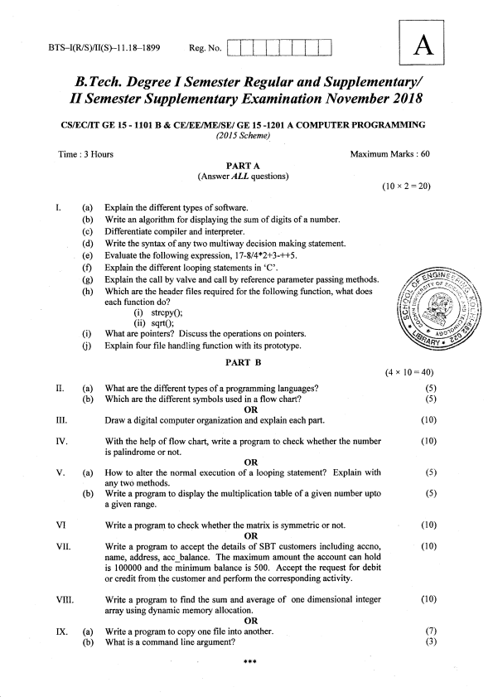
^{PART B}(4"
What are the different types of a programming languages?
Which are the different symbols used in a flow chart?
OR
Draw a digital computer organization and explain each part.
With the help of flow chart, write a program to check whether the number is palindrome or not.
OR
How to alter the normal execution of a looping statement? Explain with any two methods.
Write a program to display the multiplication table of a given number upto a given range.
Write a program to check whether the matrix is symmetric or not. OR
Write a program to accept the details of SBT customers including accno, na.me, address, acc balance. The maximum amount the account can hold is 100000 and the minimum balance is 500. Accept the request for debit or credit from the customer and perform the corresponding activity.
Write a program to find the sum and average of one dimensional integer array using dynamic memory allocation.
OR
Write a program to copy one file into another.
What is a command line argument?
***
l0 = 40)
(s)
(s)
(10)
(10)
(s)
(s)
(10)
(10)
(10)
(7)
(3)

